Pollution Monitoring

Thursday June 21, 2018

Mapping Claremont Village

**IMPORTANT NOTES**:

* Do not drive outside of testing region with scanner on -- will make formatting the map much more annoying.
* Make sure to write down all start and end times to the second
* Keep MCPC under 10 degrees.

**Schedule**:

**9:00**: Get particle scanner from Prof. Hawkins, set everything up in the clinic van and test that everything is functioning correctly before leaving.

**10:00-11:30**: Drive to the village and park somewhere on Harrison. Start the particle scanner and GPS and start on the route below. For first 4 tests travel on the provided route, for remaining tests routes can be more random to allow for data to be collected in unvisited parts. **MAKE SURE TO WRITE DOWN THE START/END TIMES FOR EVERY TEST**.

**11:30-2:00**: Return to mudd, take equipment out of van, analyze data.

**2:00-3:30**: Drive back to the village, repeat the tests from earlier.

**Route**: (450 x 715 m)

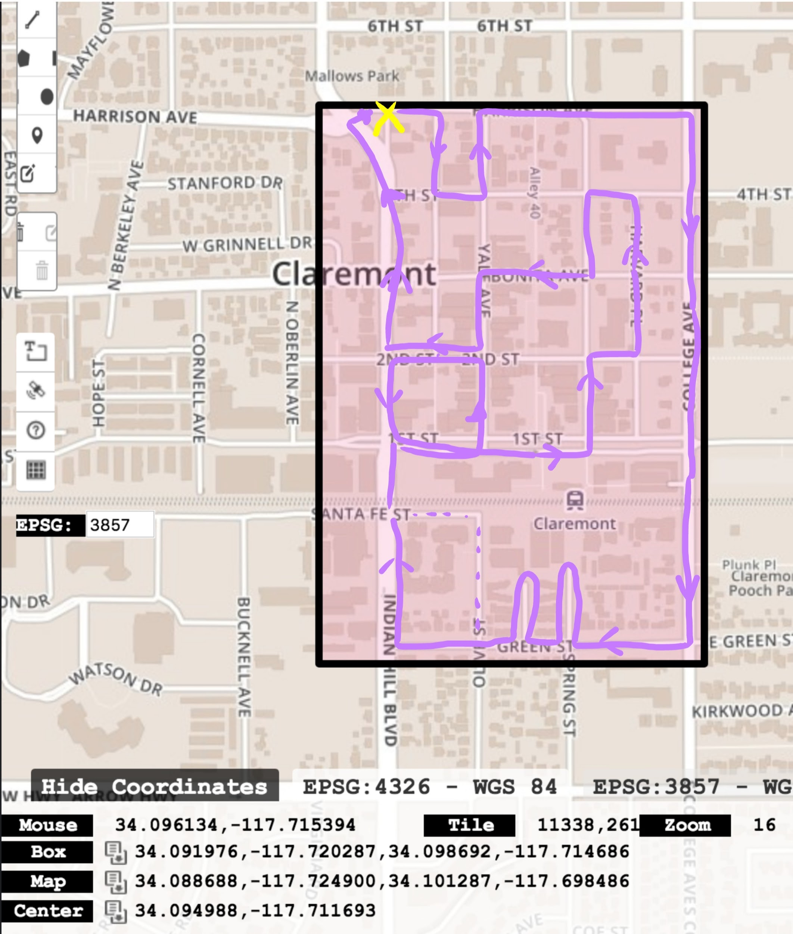

**Morning Test**:

NMEA filename: ‘coordinates5.txt’

MCPC filename: ‘MCPC_180621_101854.txt’

Start Times:

* Test 1: 17:27:02
* Test 2: 17:41:08
* Test 3: 17:56:58
* Test 4: 18:10:56
* Test 5: 18:20:23
* Test 6: 18:29:57
* End: 18:38:00

Notes:

* Test 1: construction zone on college/Bonita
* Test 2:
* Test 3:
* Test 4: stopped by train, huge spike after
* Test 5:
* Test 6:

**Afternoon Test**:

NMEA filename: ‘coordinates6.txt’

MCPC filename: ‘MCPC_180621_140639.txt’

Start Times:

* Test 1: 21:08:00
* Test 2: 21:26:15
* Test 3: 21:40:15
* Test 4: 21:50:50
* Test 5: 22:01:35
* Test 6: 22:11:25
* End: 22:21:45

Notes:

* Test 1:
* Test 2:
* Test 3:
* Test 4:
* Test 5:
* Test 6:

Key locations (approximate):

1st/IH: -2060, 354

Start/end: -1780, 335

College/green: -2190, 640

1st/Yale: -2050, 447

1st/Harvard: -2050, 547

4th/Harvard: -1840, 542

2nd/IH: -1976, 360

2nd/Yale: -1985, 446

2nd/Harvard: -1983, 545

Bonita/IH: -1910, 355

Bonita/Yale: -1910, 450

Bonita/Harvard: -1920, 544

College/first: -2030, 640

College/Harvard: -1845, 633

Post Testing Reflection:

* There seems to be a bit of lag in the particle sensor measurements. Because we’re moving as we’re testing and have a fairly long inlet hose, the measurements we’re getting are from points that are a bit behind us. In other words, the gps position and respective pollution measurement are skewed. How significant is this, and do we need to consider ways to compensate for this? Will this be a problem with the new scanners?
* The inlet hose was a bit lower in height for the second run. Does height or orientation of the inlet hose play much of a factor in the measurements we’re getting?
* Data collection code desperately needs an update:
  + It needs to output geographic coordinates, not cartesian
    - Origin is hardcoded into the code
    - Having this output in cartesian makes it harder to map the results to the locations they were actually taken.
  + Instead of having the code just write to two seperate files, we need one CSV output file with longitude, latitude, time, and concentration all in a row for a single data point.
  + For readability during testing, maybe establish a fake cartesian system where origin is set to the first point collected. Not necessary, but makes it easier to track landmarks.
* If we find a localized pollution data at a later time (afternoon, t=3), should it have an effect on previous predictions? Or should there be a greater emphasis on high coverage for training sets to find these spikes?
* How should this data be presented?